Diagram for <Accept friend request> by <Teo>
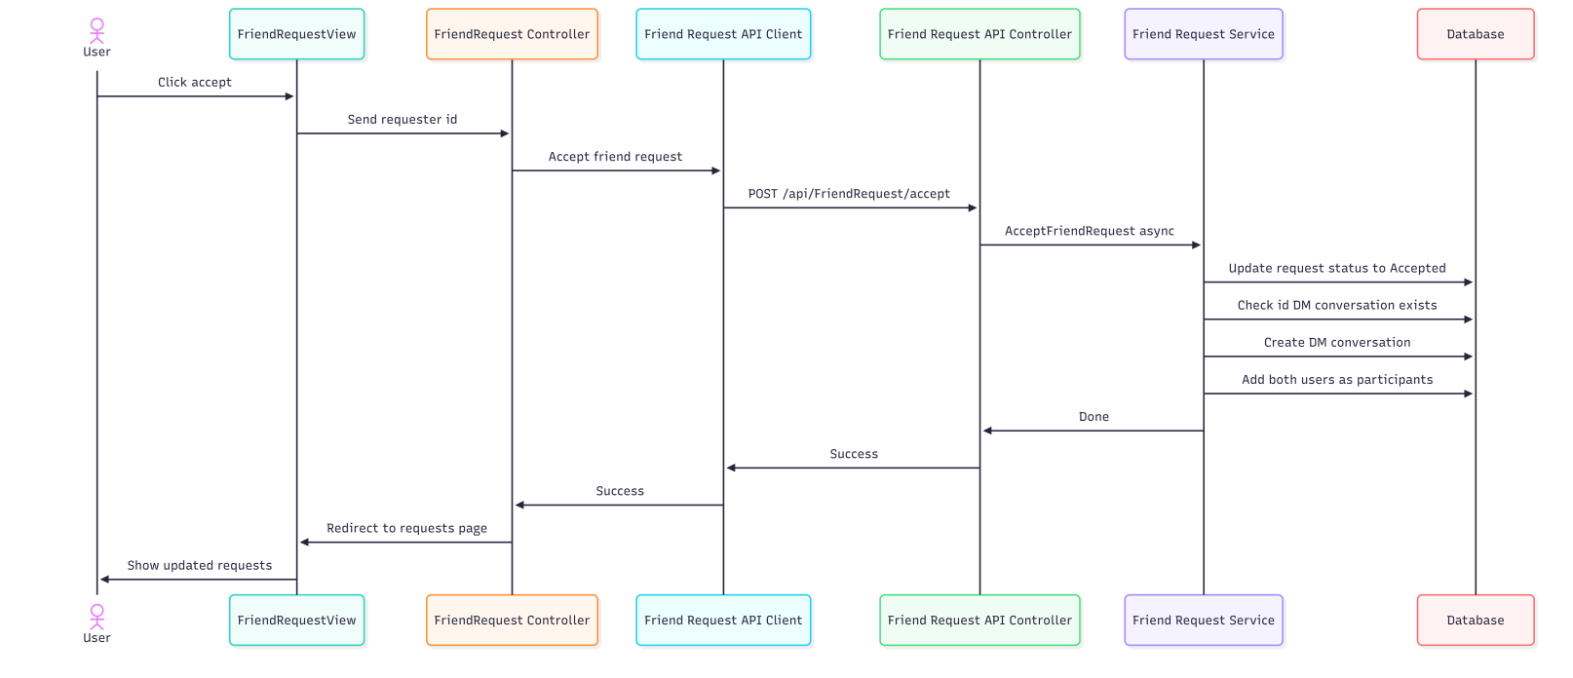
sequenceDiagram
actor A1 as User
participant P1 as FriendRequestView
participant P2 as FriendRequest Controller
participant P3 as Friend Request API Client
participant P4 as Friend Request API Controller
participant P5 as Friend Request Service
participant P6 as Database
A1->>P1: Click accept
P1->>P2: Send requester id
P2->>P3: Accept friend request
P3->>P4: POST /api/FriendRequest/accept
P4->>P5: AcceptFriendRequest async
P5->>P6: Update request status to Accepted
P5->>P6: Check id DM conversation exists
P5->>P6: Create DM conversation
P5->>P6: Add both users as participants
P5->>P4: Done
P4->>P3: Success
P3->>P2: Success
P2->>P1: Redirect to requests page
P1->>A1: Show updated requests

